Screenshots or program listings must be copied into appropriate cells in the following table.
Save this evidence document as evidence_ followed by your centre number_ candidate number, for example, evidence_ zz999_9999 and insert your name, centre number and candidate number into the header above.
Examiners must be able to read the contents including any screenshots without the use of a magnifying glass. Answers that are not readable or are missing will not be awarded any marks.
Save this evidence document at regular intervals, for example every 10 minutes.
Question 1
Part 1(a)(i)
DataArray=[] #25 elements Integer

Part 1(a)(ii)
try:
DataFile = open("Data.txt",'r')
for Line in DataFile:
DataArray.append(int(Line))
DataFile.close()
except IOError:
print("Could not find file")

Part 1(b)(i)
def PrintArray(DataArray):
output = ""
for X in range(0,len(DataArray)):
output = output + str((DataArray[X])) + " "
print(output)

Part 1(b)(ii)
PrintArray(DataArray)

Part 1(b)(iii)
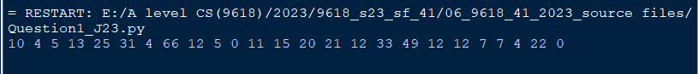

Part 1(c)
def LinearSearch(DataArray, DataToFind):
Count = 0
for X in range(0,len(DataArray)):
if (DataArray[X] == DataToFind):
Count += 1
return Count

Part 1(d)(i)
DataToFind = int(input("Enter a number to find "))
while DataToFind < 0 or DataToFind > 100:
DataToFind = int(input("Enter a number to find "))
NumberTimes = LinearSearch(DataArray, DataToFind)
print("The number", DataToFind, "is found", NumberTimes, "times")

Part 1(d)(ii)
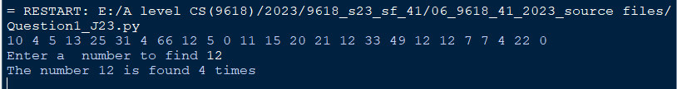

Question 2
Part 2(a)(i)
class Vehicle:
#self.__ID string
#self.__MaxSpeed integer
#self.__CurrentSpeed integer
#self.__IncreaseAmount integer
#self.__HorizontalPosition integer
def __init__(self, IDP, MaxSpeedP, IncreaseAmountP):
self.__ID = IDP
self.__MaxSpeed = MaxSpeedP
self.__IncreaseAmount = IncreaseAmountP
self.__CurrentSpeed = 0
self.__HorizontalPosition = 0

Part 2(a)(ii)
def GetCurrentSpeed(self):
return self.__CurrentSpeed
def GetIncreaseAmount(self):
return self.__IncreaseAmount
def GetHorizontalPosition(self):
return self.__HorizontalPosition
def GetMaxSpeed(self):
return self.__MaxSpeed

Part 2(a)(iii)
def SetCurrentSpeed(self, CSP):
self.__CurrentSpeed = CSP
def SetHorizontalPosition(self, HPP):
self.__HorizontalPosition = HPP

Part 2(a)(iv)
def IncreaseSpeed(self):
self.__CurrentSpeed = self.__CurrentSpeed + self.__IncreaseAmount
if (self.__CurrentSpeed > self.__MaxSpeed):
self.__CurrentSpeed = self.__MaxSpeed
self.__HorizontalPosition = self.__HorizontalPosition + self.__CurrentSpeed

Part 2(b)(i)
class Helicopter(Vehicle):
# VerticalPosition Integer
# VerticalChange Integer
# MaxHeight Integer
def __init__(self, IDP, MaxSpeedP, IncreaseAmountP, VertChangeP, MaxHeightP):
Vehicle.__init__(self, IDP, MaxSpeedP, IncreaseAmountP)
self.__VerticalPosition = 0
self.__VerticalChange = VertChangeP
self.__MaxHeight = MaxHeightP

Part 2(b)(ii)
def IncreaseSpeed(self):
self.__VerticalPosition = self.__VerticalPosition + self.__VerticalChange
if (self.__VerticalPosition > self.__MaxHeight):
self.__VerticalPosition = self.__MaxHeight
Vehicle.SetCurrentSpeed(self, Vehicle.GetCurrentSpeed(self) + Vehicle.GetIncreaseAmount(self))
if (Vehicle.GetCurrentSpeed(self) > Vehicle.GetMaxSpeed(self)):
Vehicle.SetCurrentSpeed(self, Vehicle.GetMaxSpeed(self))
Vehicle.SetHorizontalPosition(self, Vehicle.GetHorizontalPosition(self) + Vehicle.GetCurrentSpeed(self))

Part 2(c)
def OutputCurrentPosition(self):
print("Current position = ", self.__HorizontalPosition)
print("Current speed = ", self.__CurrentSpeed)
def OutputCurrentPosition(self):
print("Current position = ", Vehicle.GetHorizontalPosition(self))
print("Current speed = ", Vehicle.GetCurrentSpeed(self))
print("Current vertical position = ", self.__VerticalPosition)

Part 2(d)(i)
#main
Car = Vehicle ("Tiger", 100, 20)
Heli1 = Helicopter("Lion", 350, 40, 3, 100)
Car.IncreaseSpeed()
Car.IncreaseSpeed()
Car.OutputCurrentPosition()
print("")
Heli1.IncreaseSpeed()
Heli1.IncreaseSpeed()
Heli1.OutputCurrentPosition()

Part 2(d)(ii)
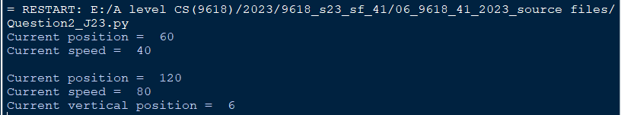

Question 3
Part 3(a)
global Animal
global Colour
Animal = [] #20 elements
Colour = [] #10 elements
global AnimalTopPointer
global ColourTopPointer
AnimalTopPointer = 0
ColourTopPointer = 0

Part 3(b)(i)
def PushAnimal(DataToPush):
global Animal
global AnimalTopPointer
if AnimalTopPointer == 20:
return False
else:
Animal.append(DataToPush)
AnimalTopPointer += 1
return True

Part 3(b)(ii)
def PopAnimal():
global Animal
global AnimalTopPointer
if AnimalTopPointer == 0:
return ""
else:
ReturnData = Animal[AnimalTopPointer - 1]
AnimalTopPointer -=1
return ReturnData

Part 3(b)(iii)
def ReadData():
try:
global Animal
global AnimalTopPointer
AnimalFile = open("AnimalData.txt",'r')
for Line in AnimalFile:
PushAnimal(Line.strip())
AnimalFile.close()
except IOError:
print("Could not find file")

Part 3(b)(iv)
def PushColour(DataToPush):
global Colour
global ColourTopPointer
if ColourTopPointer == 10:
return False
else:
Colour.append(DataToPush)
ColourTopPointer +=1
return True

def PopColour():
global Colour
global ColourTopPointer
if ColourTopPointer == 0:
return ""
else:
ReturnData = Colour[ColourTopPointer - 1]
ColourTopPointer -=1
return ReturnData

Part 3(b)(v)
def ReadData():
try:
global Colour
global ColourTopPointer
global Animal
global AnimalTopPointer
AnimalFile = open("AnimalData.txt",'r')
for Line in AnimalFile:
PushAnimal(Line.strip())
AnimalFile.close()
ColourFile = open("ColourData.txt",'r')
for Line in ColourFile:
PushColour(Line.strip())
ColourFile.close()
except IOError:
print("Could not find file")

Part 3(c)
def OutputItem():
global Colour
global ColourTopPointer
global Animal
global AnimalTopPointer
ColourReturned = PopColour()
AnimalReturned = PopAnimal()
if ColourReturned == "":
print("No colour")
PushAnimal(AnimalReturned)
else:
if AnimalReturned == "":
print("No animal")
PushColour(ColourReturned)
else:
print(ColourReturned, AnimalReturned)

Part 3(d)(i)
ReadData()
OutputItem()
OutputItem()
OutputItem()
OutputItem()

Part 3(d)(ii)
